**l-Shaykh, Hanan (1945-)**

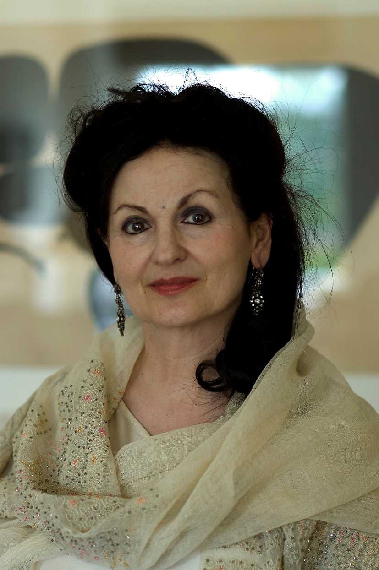

SUMMARY

Hanan al-Shaykh (Ḥanān al-Shaykh حنان الشيخ) is one of the most important voices of contemporary Arabic literature. She has written essays, novels, short stories and several plays for theatre. She was born in Lebanon and began to publish in a newspaper when she was only 14. After her college studies in Egypt she returned to Lebanon, but in 1976 she had to leave the country due to the civil war. At first she lived in Saudi Arabia, but since 1982 she has lived in London with her family. The war and its consequences, sexual repression, and the hypocrisy in religion all are important components of her writing. Her novels have been translated into 20 languages (among them English, French, Spanish and Korean). Many of her novels have achieved major success among both the critics and the reading public, for instance *The Story of Zahra* (1980), *Women of Sand and Myrrh* (1988), *Beirut Blues* (1992), *This is London* (2000), and *The Locus and the Bird: My Mother’s Story* (2009). Hanan al-Shaykh also revisited the popular *One Thousand and One Nights* (2011).

**Hanan al-Shaykh** (url: <http://www.openbookontario.com/news/brief_history_one_thousand_and_one_nights_story_behind_stories>

MAIN ENTRY

Hanan al-Shaykh was born in Beirut, to a Muslim Shii family. She received a classical education at a girls’ schools in Beirut and then studied at the American College in Cairo (1963-1966). She returned to Lebanon, where she worked as a journalist for several newspapers and for television. During the Civil War she lived in Saudi Arabia from 1976 to 1982 and then moved to England, where she currently lives. She began to write essays when she was teenager, but soon felt more comfortable writing fiction.

Al-Shaykh published *The Story of Zahra* (1980), a novel set in the Lebanese Civil War, at her own expense due to the censorship in Lebanon. It was the first of her works to attract international attention. Zahra (who symbolizes Lebanon) is an ugly girl trying to survive in the middle of the war. After some terrible episodes in her short life, including divorce and several abortions, Zahra falls in love with a sniper, a desperate gesture that ends in tragedy. *Beirut Blues* (1992), also about the war, is written as a set of letters addressed to real and symbolic recipients in an attempt to find sense and humanity in the middle of chaos and destruction.

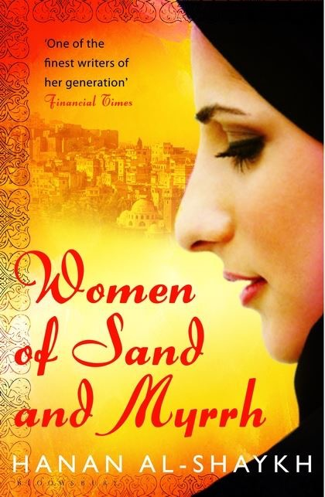*Women of Sand and Myrrh* (1992), set in an unspecified country in the Middle East, explores the everyday life of four women, their ambitions, sexuality, and intimacy in an oppressive male chauvinist society. In *The Locus and the Bird. My Mother’s Story* (2009) al-Shaykh traces the biography of her mother, an independent woman who decided to leave her family to follow her own way in life.

# In her last works (*Only in London* and the *Virgins of Londonistan*) she explores Arab society in England, depicting the ghettos in which they live and the difficult position of those who are caught between Eastern and Western identities. In fact, after more than thirty years living in Europe, she has declared that she is no longer able to write about Arab countries.

# Her style is innovative and has created a new way of showing contemporary Arab life in plain language, revealing women’s fight for freedom, the right to choose their own sexuality, and religious expression, all while expressing a continuous feeling of dislocation and solitude.

# Hanan al-Shaykh has received many literary awards. For instance, *Women of Sand and Myrrh* was chosen as one of the 50 Best Books of 1992 by Publishers Weekly and *Only in London* was preselected for the Independent Foreign Fiction Prize in 2002. In France, where her work has been very well received, *The Locus and the Bird* was awarded the Prix du Roman Arabe in 2011.

**List of Works**

Novels

*Intiḥār rajul mayyit* (انتحار رجل ميت *Suicide of a Dead Man,* 1970)

*Faras al-Shayṭān* (فرس الشيطان - *The Devil’s Horse,* 1975)

Ḥikāyat Zahra (حكاية زهرة  *- The Story of Zahra,* 1980 trans. 1994)

*Misk al-Gazāl* (مسك الغزال *- Scent of a Gazelle,* 1988trans. *Women of Sand and Myrrh* 1992)

*Barīd Bayrūt* (بريد بيروت *- Mail from Beirut*, 1992, trans. *Beirut Blues* 1992)

*Imra’atāni ‘alà shaṭi al-baḥr* (امراتان على شاطئ البحر -*Two Women by the Sea* 2003)

*Ḥikāyatī sharḥ yaṭūl* (, حكايتي شرحٌ يطول  *- My story has a long explanation*, trans. *The Locus and the Bird: My Mother’s Story* 2009)

*Innaha Lundun*, ‘azīzī (إنها لندن يا عزيزي *- This is London, Dear* 2000, trans. *Only in London 2001*)

*‘Adhrà Lundunistān* (عذارى لندنستان - *The Virgins of Londonistan* 2014)

Short story collections

*The Persian Carpet* in Arabic Short Stories (1983)

*Aknus al-shams ‘an al-suṭūḥ* (أكنس الشمس عن السطوح, *I Sweep the Sun Off Rooftops* 1994, trans. 2002)

*One Thousand and One Nights. A new re-imagining* (2013)

Drama

*Dark Afternoon Tea* (1993)

*Paper Husband* (1997)

**Further reading**

Ball, Anna (2011) “Things That Walk With Me. Hanan Al-Shaykh in Conversation”, *Wasafiri* 26:1, 62-66, DOI: 10.1080/02690055.2011.534295, Available at: <http://dx.doi.org/10.1080/02690055.2011.534295>

Fadda-Conrey, Carol (2003) “Exilic Memories of War: Lebanese Women Writers Looking Back” . Studies in the Humanities-Indiana, 30 1-2, 7-20.

Hout, Syrine C. (2003) “Going the Extra Mile: Redefining Identity, Home and Family in Hanan al-Shaykh’s *Only in London”* Studies in Humanities-Indiana 30.1-2, 29-45.

El-Ariss, Tarek (2013) Majnun Strikes Back: Crossing of Madness and Homosexuality in Contemporary Arabic Literature, International Journal of the Middle East Studies 45, 293-312. doi:10.1017/S0020743812001626

Mehta, Brinda () *Rituals of Memory*

Langer, Jennifer (2004) “Crossing Borders: The Extent to Which the Voices of Exiled and Refugee Women Have Adapted to their New Western Diasporic Space”, *Journal of Internatnional Women’s Studies* 5:3, 66:74. Available at: <http://vc.bridgew.edu/jiws/vol5/iss3/7>

**Youtube:**

Hanan Al-Shaykh @5x15 – The Locus and the Bird <https://www.youtube.com/watch?v=QRC2W6Wv9lA>

Hanan al-Shaykh with Ester Freud – World Literature Weekend 2009 <https://www.youtube.com/watch?v=ddxVtrqfxjs>

Hanan al-Shaykh Reads Only in London PEN America <https://www.youtube.com/watch?v=G32S-AJ-quY>

Mònica Rius-Piniés, University of Barcelona

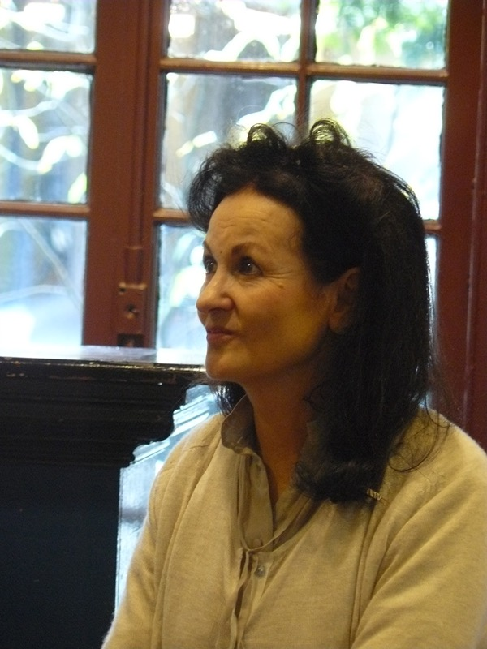

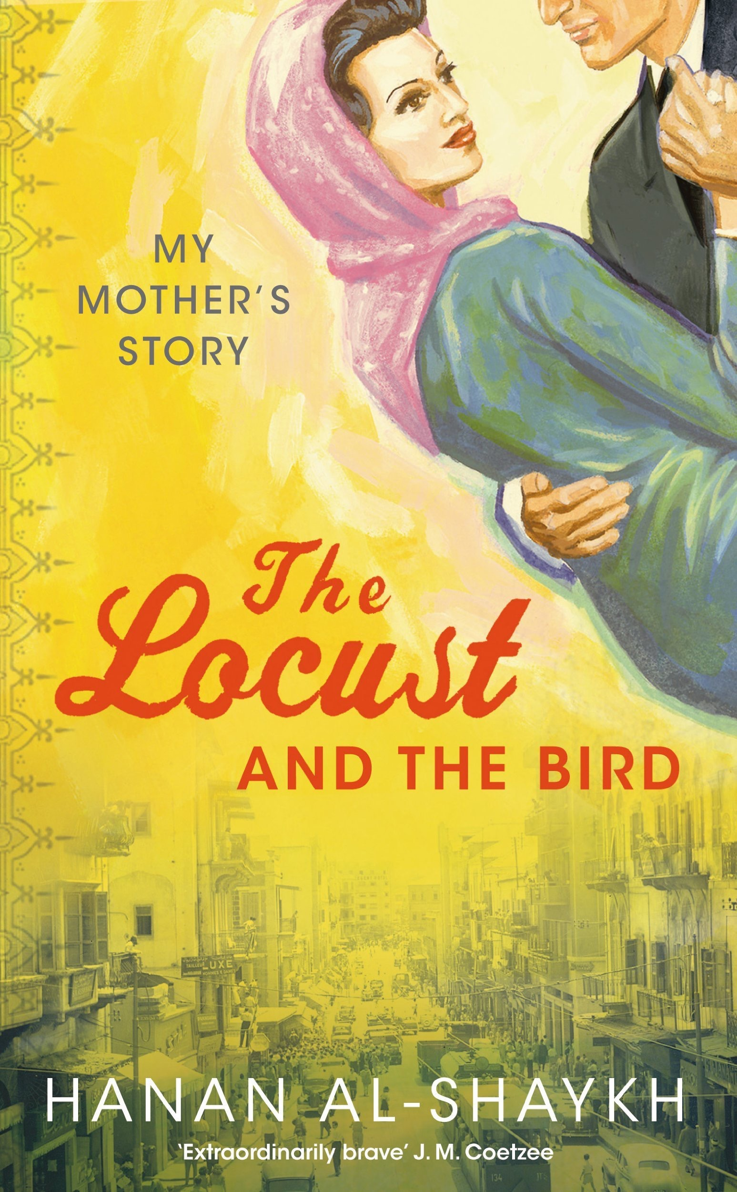/

Hanan al-Shaykh by [kellywritershouse](https://www.flickr.com/photos/kellywritershouse/)

https://www.flickr.com/photos/kellywritershouse/7004474343